3.1 Database Design
Database systems are designed to manage large bodies of information. These large bodies of information do not exist in isolation. They are part of the operation of some enterprise whose end product may be information from the database or may be some device or service for which the database plays only a supporting role.
Database design mainly involves the design of the database schema. The design of a complete database application environment that meets the needs of the enterprise being modeled requires attention to a broader set of issues.
3.1.1 Design Process
A high-level data model provides the database designer with a conceptual framework in which to specify the data requirements of the database users, and how the database will be structured to fulfill these requirements. The initial phase of database design, then, is to characterize fully the data needs of the prospective database users. The database designer needs to interact extensively with domain experts and users to carry out this task. The outcome of this phase is a specification of user requirements.
Next, the designer chooses a data model, and by applying the concepts of the chosen data model, translates these requirements into a conceptual schema of the database. The schema developed at this conceptual-design phase provides a detailed overview of the enterprise. The designer reviews the schema to confirm that all data requirements are indeed satisfied and are not in conflict with one another. The designer can also examine the design to remove any redundant features. The focus at this point is on describing the data and their relationships, rather than on specifying physical storage details.
In terms of the relational model, the conceptual-design process involves decisions on what attributes we want to capture in the database and how to group these attributes to form the various tables. The “what” part is basically a business decision, and we shall not discuss it further in this text. The “how” part is mainly a computer-science problem. There are principally two ways to tackle the problem. The first one is to use the entity-relationship model (Section 3.1.2); the other is to employ a set of algorithms (collectively known as normalization) that takes as input the set of all attributes and generates a set of tables (Section 3.1.3).
A fully developed conceptual schema indicates the functional requirements of the enterprise. In a specification of functional requirements, users describe the kinds of operations (or transactions) that will be performed on the data. Example operations include modifying or updating data, searching for and retrieving specific data, and deleting data. At this stage of conceptual design, the designer can review the schema to ensure it meets functional requirements.
The process of moving from an abstract data model to the implementation of the database proceeds in two final design phases. In the logical-design phase, the designer maps the high-level conceptual schema onto the implementation data model of the database system that will be used. The designer uses the resulting system-specific database schema in the subsequent physical-design phase, in which the physical features of the database are specified. These features include the form of file organization and the internal storage structures.
3.1.2 The Entity-Relationship Model
The entity-relationship (E-R) data model uses a collection of basic objects, called entities, and relationships among these objects. An entity is a “thing” or “object” in the real world that is distinguishable from other objects. For example, each person is an entity, and bank accounts can be considered as entities. Entities are described in a database by a set of attributes. A relationship is an association among several entities. The set of all entities of the same type and the set of all relationships of the same type are termed an entity set and relationship set, respectively.
The overall logical structure (schema) of a database can be expressed graphically by an entity-relationship (E-R) diagram. There are several ways in which to draw these diagrams. One of the most popular is to use the Unified Modeling Language (UML).
E-R diagram is graphical representation of an E-R model. As depicted in the previous diagrams, the set of symbols (building blocks) to represent E-R diagram.
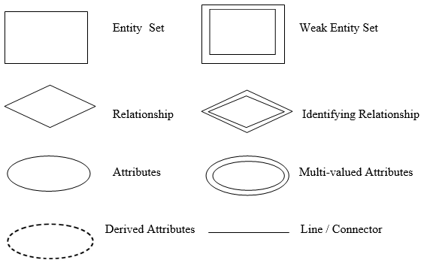
Figure 3.1 (a) Symbol of E-R Diagram
There are three types of relationships between entities:
- One-to-one (1 to 1): one instance of an entity (A) is associated with one other instance of another entity (B).
- One-to-many (1 to N): one instance of an entity (A) is associated with zero, one or many instances of another entity (B), but for one instance of entity B there is only one instance of entity A.
- Many-to-many (N to N): one instance of an entity (A) is associated with one, zero or many instances of another entity (B), and one instance of entity B is associated with one, zero or many instances of entity A.
3.1.3 Normalization
Another method for designing a relational database is to use a process commonly known as normalization. The goal is to generate a set of relation schemas that allows us to store information without unnecessary redundancy, yet also allows us to retrieve information easily. The approach is to design schemas that are in an appropriate normal form. To determine whether a relation schema is in one of the desirable normal forms, we need additional information about the real-world enterprise that we are modeling with the database. The most common approach is to use functional dependencies.

3.1.4 System’s Entity-Relationship (ER) Diagram with Description
A database table organizes the information of a single topic into rows and columns. Tables can store many records, from a few numbers for a small database up to millions for a large company database. In our project the database table contains the tables of The Documenting of The Freedom Fighters in Bangladesh. Each table contains some attributes. The database tables are shown below-
- Fighter Information Table
- Sector Information Table
- Birsrestho Information Table
- Multimedia File Table
- Deed Table
These tables are described below one after one-
- Fighter Information Table
The Fighter Information Table is the basic information table of a freedom fighter. It has recorded all the information of a freedom fighter like name, district, date of birth, gadget no, fighters id, muktibarta no, rank, sector commander, photo, video, speech of a freedom fighter, etc.
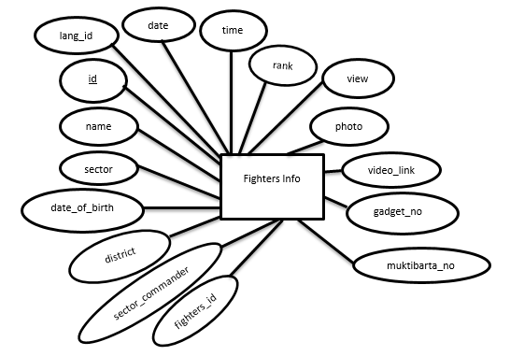
Table 3.1 (a) Fighters Information Table
It has the following attributes-
- id: The id is a primary key of Fighters Information Table. It identifies each freedom fighters unique information in bangla and english. It is auto increment.
- lang_id: The lang_id is used to identify the fighter’s information in Bangla and English.
- name: The name is identified the fighter’s name.
- district: The district is identified the fighter’s district where he was born.
- date_of_birth: The date_of_birth is identified the fighter’s date of birth.
- gadget_no: The gadget_no is identified the fighter’s government facility no. Every freedom fighter’s has a unique gadget no in Bangladesh.
- fighters_id: Every fighter’s has a unique id. This id is used for their identity in ministry database.
- muktibarta_no: The muktibarta_no is the freedom fighters Indian identity no. It gives them Indian government. Every freedom fighter who trained in India has a muktibarta no.
- sector: The sector is the sector name where the freedom fighter’s was fight.
- rank: The rank is the freedom fighters rank such as muktibahinee, commander, subsector commander etc.
- sector_commander: The sector_commander is the freedom fighters sector commander name, the fighter’s was fight which commander under.
- description: The discription is the freedom fighter’s details and speech.
- photo: The photo is identified the fighter’s photo.
- video_link: The video_link is the fighter’s video conversation link which situated in the YouTube.
- view: The view is used to count view, how many time the fighter’s information is view to the people.
- time: The time is the time, used when the fighter’s information is upload in our database.
- date: The date is used for date, when the fighter’s information is upload in our database.
- Sector Information Table
The Sector Information Table is the basic information table of the Sectors in Bangladesh. In this table, it has many attributes like id, sector name, sector description, view count, time, date, etc.
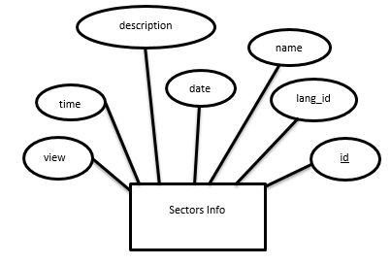
Table 3.1 (b) Sectors Information Table
It has the following attributes-
- id: The id is a primary key of Sectors Information Table. It identifies each sector unique information in bangla and english. It is auto increment.
- lang_id: The lang_id is used to identify the sector information in Bangla and English.
- name: The name is identified the sector name.
- descrption: The discription is the sector’s description where we know the area, commander and sub-commander of sector.
- view: The view is used to count view, how many time these sector information is view to the people.
- time: The time is the time, used when the sector information is upload in our database.
- date: The date is used for date, when the sector information is upload in our database.
- Birsrestho Information Table
The Birsrestho Information Table is the basic information table of the Birsrestho in Bangladesh. It has recorded all the information of the Birsrestho in Bangladesh. In this table, it has name, address, date_of_birth, sector, rank, photo, view, description, etc. attributes.
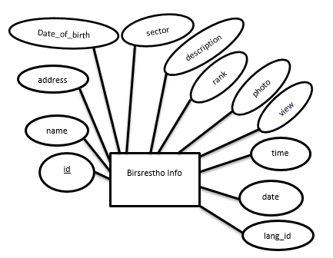
Table 3.1 (c) Birsresthos Information Table
It has the following attributes-
- id: The id is a primary key of Birsrestho’s Information Table. It identifies each Birsrestho’s unique information in bangla and english. It is auto increment.
- lang_id: The lang_id is used to identify the Birsrestho’s information in Bangla and English.
- name: The name is identified the Birsrestho’s name.
- address: The address is identified the Birsrestho’s address where he was born.
- date_of_birth: The date_of_birth is identified the Birsrestho’s date of birth.
- sector: The sector is the sector name where the Birsrestho was fought.
- rank: The rank is the Birsrestho’s rank such as lieutenant, cornel, sepoy etc.
- descrption: The discription is the Birsrestho’s details information.
- photo: The photo is identified the Birsrestho’s photo.
- view: The view is used to count view, how many time the Birsrestho’s information is view to the people.
- time: The time is the time, used when the Birsrestho’s information is upload in our database.
- date: The date is used for date, when the Birsrestho’s information is upload in our database.
- Multimedia File Table
Two types of Multimedia File Table are audio table and video table. In audio table and video table, it has some attributes.
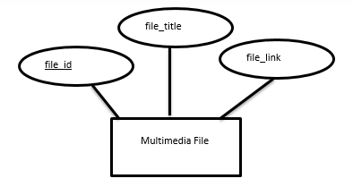
Table 3.1 (d) Multimedia File Table
The Multimedia File Table has the following attributes-
- file_id: It is the primary key of this table that is uniquely defines for every multimedia track. It is auto incremented.
- file_title: It indicates multimedia track’s title.
- file_link: It used to store the multimedia track link for fighters.
- Deed Table
The Deed table is used to manage uploaded deed about freedom fighters in Bangladesh.
It has the following attributes-
- deed_id: It is the primary key of this table that is uniquely defines for every deed or document. It is auto incremented.
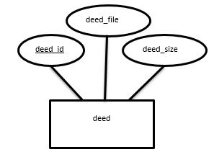
Table 3.1 (e) Deed Table
- deed_file: It indicates deed file name or title.
- deed_size: It used to store the deed or document name with extension.
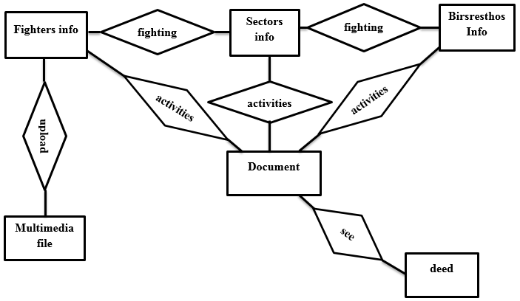
Figure 3.1 (b) Entity Relationship (E-R) Diagram

3.2 System Design
Systems design is the process of defining the architecture, components, modules, interfaces, and data for a system to satisfy specified requirements. Systems design could be seen as the application of systems theory to product development. The goal of system design are-
- The design must implement all of the explicit requirements contained in the analysis model, and it must accommodate all of the implicit requirements desired by the customer.
- The design must be a readable, understandable guide for those who generate code and for those who test and subsequently support the software.
- The design should provide a complete picture of the software, addressing the data, functional, and behavioral domains from an implementation perspective.
The system design provides details about software data, architecture, interfaces, and components that are necessary to implement the system. Data design is created by transforming the analysis model class-based elements into classes and data structures required to implement the software. Architectural design defines the relationships among the major structural elements of the software. Interface design describes how the software elements, hardware elements, and end-users communicate with one another. The purpose of component-level design is to define data structures, algorithms, interface characteristics, and communication mechanisms for each software component identified in the architectural design. Component-level design occurs after the data and architectural designs are established.
3.2.1 Users of Fighters71
- Student: Liberation war history is very important for a student. In online, there are huge information about various things but limited information about Bangladeshi liberation war. So student can’t find enough information about our liberation war. Student can use this website to know the real history of liberation war, knowing about freedom fighters, sector, birsrestho, etc.
- Foreigner: Liberation war of Bangladesh is very historical in the world. So, if any foreigner want to know that, then he/she can visit this website.
- Government Bodies: Government people is all time busy for governing the country. They have not enough time to know about freedom fighters and their dream. If government people use this website, then he/she know the freedom fighters and their dream about Bangladesh.
- General People: If any people have interested about knowing freedom fighters and liberation war, then he/she can use this website. People may know about the real history.
3.2.2 Navigation menu of Fighters71
Menu is very important for a website. Each menu contain various information. Fighters71 has also some menu for user. There are Home, Document, Sector, Birsrestho, Gallery and Download.
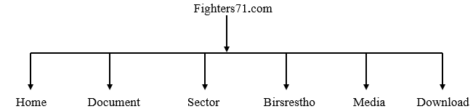
Figure 3.2 (b) Navigation menu of Fighters71
Fighters71 has a multiple language select option. User may use bengali and english language but bengali is the default language.
- Home: Home is the main page of Fighters71 website. Users may know about the liberation war history of Bangladesh.
- Document: Document part contains several freedom fighters speech. Users get a list of freedom fighters and click details button for knowing about details information. Each details information page contains a video conversation.
- Sector: In liberation war, Bangladesh was divided into eleven sectors. Each sector has some area, sector commander, sub-sector commander. Fighters71’s sector has a dropdown menu and each sector contains the total history of a sector like areas, sector commander, sub-sector commander and the birsrestho of that sector.
- Birsrestho: Birsrestho’s are the national heroes of Bangladesh. Bangladesh has seven birsresthos. In Fighters71, Birsrestho menus has a dropdown menu where all birsrestho names are showing. Select any birsrestho and know about him.
- Media: Media has a dropdown menu. It has three part- Audio, Video and Gallery. Audio contains only the Audio file like freedom fighters speech and so on. Video contains the live speech of freedom fighters, speech of Bongobondhu Shekh Mujibur Rahman, movie and documentary of liberation war. Gallery contains various photos related to liberation war.
- Download: Download also has a dropdown menu. It has two part- Deed and E-book. Deed contains various deed’s file related to liberation war and E-book contains various books related to liberation war.
3.3 Flow Diagram
Flow diagram is a collective term for a diagram representing a flow or set of dynamic relationships in a system. The term flow diagram is also used as a synonym for flowchart, and sometimes as a counterpart of the flowchart. Flow diagrams are used to structure and order a complex system, or to reveal the underlying structure of the elements and their interaction.
3.3.1 Flow Diagram of Viewing Details of Document
In this system, if user wants to see fighters documents, he/she able to select the Document for the navigation menu. A user needs some instructions to see the documents of fighters. Firstly a user needs to access the website and then to go to the website menu. Based on the Website; if a user wants to see the Documents of the freedom fighters then the user had to go to the List of Fighters menu. If not, the process is terminated. If he/she wants to see the list of fighters then need to go to the details option and had to go to the fighters details and after viewing the Fighters Details then the process is terminated. If not, the process is terminated.
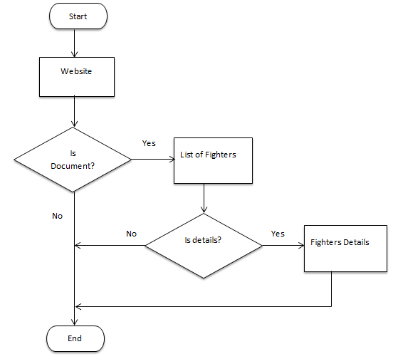
Figure 3.3 (a) Flow Diagram of viewing details of Document
3.3.2 Flow Diagram of Viewing Details of Sector
In this system, it has eleven sectors briefly description. The sector will be found of our system in the navigation menu. If user wants to select a sector from the navigation menu, user found the description and fighters list of this sector. Otherwise he/she will not able to see the sector details of this system. For this reason, a user needs to take some direction from the flow diagram. First of all, a user needs to select the start option then had to go to the website menu. Depend upon the website; if a user wants to see the Sectors of the freedom fighters then the user had to go to the Sectors List of fighters. Otherwise the process is terminated. If a user wants to see the details of sector list then had to go to the Sector Details menu. Otherwise the process is terminated. After seeing the Sector Details then the process is terminated.
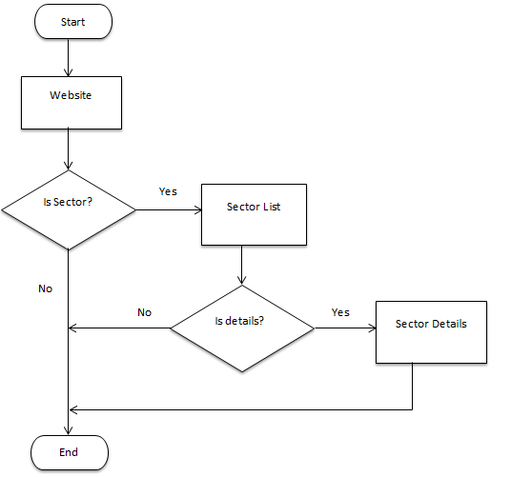
Figure 3.3 (b) Flow diagram of viewing details of Sector
3.3.3 Flow Diagram of Viewing Details of Birsrestho
In this system, if user want to see the birsrestho details, he/she able to select the Birsrestho from the navigation menu where has a list of seven birsrestho in Bangladesh. If user select one birsrestho from the list, then he/she see that birsrestho’s briefly description. From Birsrestho list if user do not select any one, he/she will not able to see birsrestho details. For this reason, a user needs to take some direction from the flow diagram of Birsrestho. First of all, a user needs to access the website. Depend upon the Website; if a user wants to see the Birsrestho of the freedom fighters then the user had to go to the List of Birsrestho. Otherwise the process is terminated. If a user wants to see the Details of Birsrestho then had to go to the Birsrestho Details menu. Otherwise the process is terminated. After seeing the Birsrestho Details then the process is terminated.
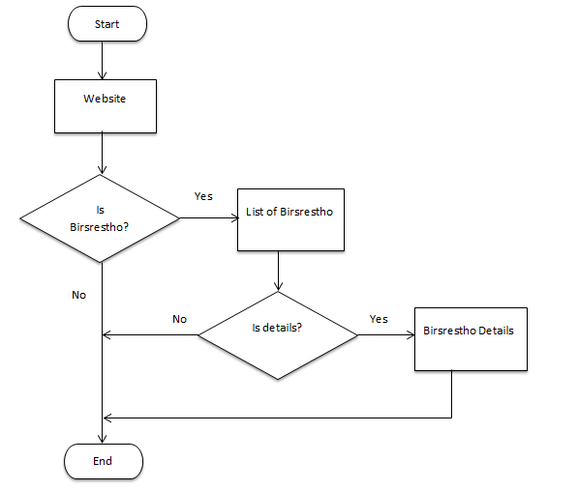
Figure 3.3 (c) Flow diagram of viewing details of Birsrestho
3.3.4 Flow Diagram of Accessing Multimedia File
In our system, the Media menu consists of audio, video and photo gallery that’s all are freedom fighters and liberation war related. It will be found of our system in the navigation menu. If anyuser select one, he/she will see the selected part; otherwise will not see. For this reason, a user needs to take some direction from the flow diagram of multimedia file. First of all, a user needs to access the website. Depend upon the Website; if a user wants to see the Media of the freedom fighters then the user had to go to the Audio, Video and Gallery menu. Otherwise the process is terminated. If a user wants to see the Audio file then had to go to the Audio List menu. Otherwise the process is terminated. After seeing the Audio then the process is terminated. In the similarly way, a user can see the Video and Gallery file.

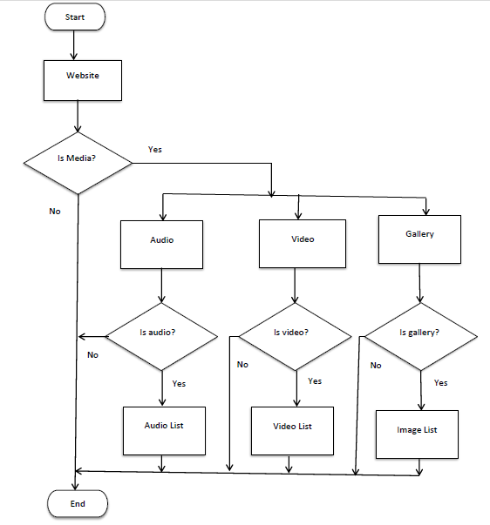
Figure 3.3 (d) Flow diagram of accessing multimedia file
3.3.5 Flow Diagram of Downloading Deed and E-book File
If any user want to download deed or e-book about liberation war related, user could be download from our system. The download option is found in navigation menu. If anyuser select between deed and e-book, he/she will see a list of downloaded deeds or e-book. For this reason, a user needs to take some direction from the flow diagram of flow diagram of downloading deed and e-book file. For this, a user needs to access the website. Depend upon the Website; if a user wants to Download Deed and E-book file of the freedom fighters then the user had to go to the Deed menu. Otherwise the process is terminated. If a user wants to download the Deed file then had to go to the Deed List menu. Otherwise the process is terminated. After Downloading the Deed file then the process is terminated. In the similarly way, a user can Download the E-book file.
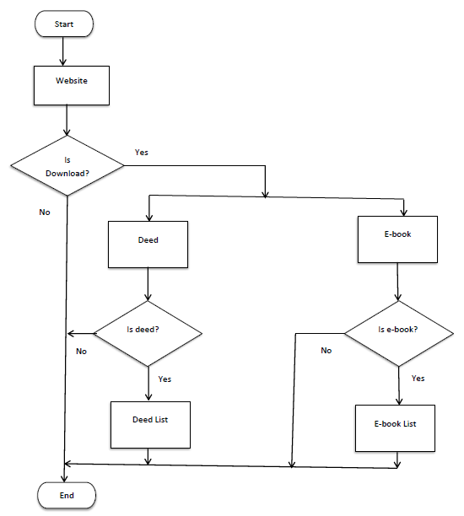
Figure 3.3 (e) Flow diagram of downloading deed and e-book file
3.3.6 Flow Diagram of Navigating the System
In this system, if user wants to change the language of the documentation of freedom fighters, he/she able to select the Change Language for the navigation menu. A user needs some instructions to change the language of the documentation of freedom fighters. First of all, a user needs to access the website. Based on the Website; if a user wants to change the language of this website then the he/she had to go to the change language button. Otherwise the Language to be Bangla. If user wants to translate contents that is Bangla to English or English to Bangla then user had to go to the continue. Otherwise the process is terminated. 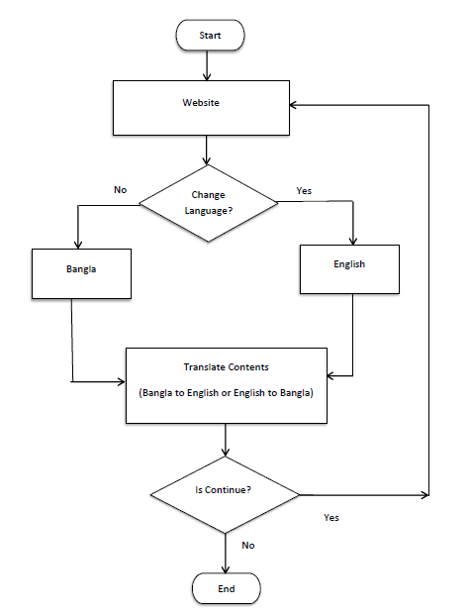
Figure 3.3 (f) Flow diagram of navigating the system

